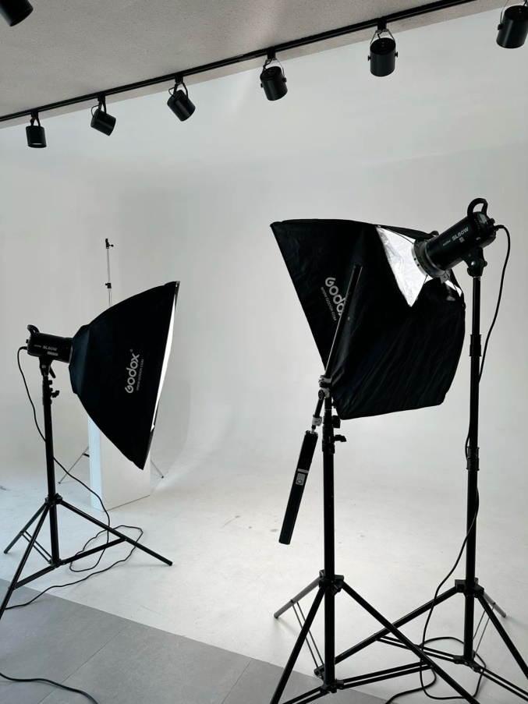

What to pay attention to before taking photos and videos.

1. Do I need a makeup artist service?

Teamwork determines the result. The makeup artist will help to even out the skin tone, hide circles under the eyes, and sculpt the oval of the face. Theoretically, this can be done later in a graphic editor. However, the uniqueness of a good photo lies in the minimal post-processing of the received frames. Make-up artists use professional tools that will not add glare, will not distort colors and will not flow under the light of lamps.

It is advisable for men not to get a haircut on the day of shooting.

A slight unshaven appearance can add masculinity and looks much more attractive than red spots from a recent shave. A prerequisite is clean hair and fresh styling. Don't forget to put your hands in order. For men, neatly filed nails and the absence of burrs are no less important than for women.

In no case is it recommended to abuse alcohol on the eve of a visit to a photo studio.

2. What can be improved with retouching?

Modern photography consists of two stages: shooting and post-processing. Post-processing includes: retouching, color correction and geometry editing. The detail and texture of the source file should not scare you: after post-processing, it will make an excellent glossy frame.

3. Which clothes should be preferred when creating a business portrait?

Choose a classic suit if you adhere to a conservative style or casual — to create a modern dynamic image.

It is better to bring clothes with you — on the way to the studio or office, things may get wrinkled or dirty.

Don't forget the accessories — tie, cufflinks, watch. It is better to choose jewelry that is not too large and inconspicuous.

The shoes must be in perfect condition. But do not forget about the convenience. It is difficult to assume a free natural pose if the shoes are tight. It is better for women not to wear too high heels. It is advisable to carry new shoes in advance.